JavaTM 2 Enterprise Edition

XML API for JavaTM Transactions

JSR 156

Specification Lead:
Mark Little
Hewlett-Packard

Technical comments:

Version 0.1
Expert Group Draft
Trademarks
Java, J2EE, Enterprise JavaBeans, JDBC, Java Naming and Directory Interface are trade-marks or registered trademarks of Sun Microsystems, Inc. in the U.S. and other countries.
Table of Contents
1. Introduction 5
1.1 Scope 6
1.2 Target Audience 6
1.3 Organization 6
1.4 Document Convention 7
1.5 J2EE Activity Service Expert Group 7
1.6 Acknowledgements 9
2. Overview 11
2.1 When ACID is too strong 12
2.2 Existing techniques 15
2.3 Overall aim 16
3. JAXTX architecture 19
3.1 Architecture components 20
3.2 Users and interfaces 22
3.3 Combining implementations 23
4. JAXTX components 25
4.1 Features 25
4.1.1 Client interaction interface 25
4.1.2 Extended client interfaces 25
4.1.3 Generic coordinator interface 26
4.1.4 Participant interface 26
4.1.5 Service and context management interface 26
4.1.6 XML configuration data 26
4.2 JAXTX packages 26
4.2.1 javax.jaxtx package 27
5. Transaction model definitions 37
6. References 39

Introduction
This document describes the system design and interfaces for XML based transactions. JAXTX is the realization, within the J2EE programming model, of work that has been conducted in various commercial, academic, and standards organizations into enabling Web Services with the critical transactional capabilities that they need.
An increasingly large number of distributed applications are constructed by being composed from existing applications. The resulting applications can be very complex in structure, with complex relationships between their constituent applications. Furthermore, the execution of such an application may take a long time to complete, and may contain long periods of inactivity, often due to the constituent applications requiring user interactions. In a loosely coupled environment like the Web, it is inevitable that long running applications will require support for fault-tolerance, because machines may fail or services may be moved or withdrawn. A common technique for fault-tolerance is through the use of atomic transactions, which have the well know ACID properties, operating on persistent (long-lived) objects. Transactions ensure that only consistent state changes take place despite concurrent access and failures.
Traditional transaction processing systems are sufficient if an application function can be represented as a single top-level transaction. Frequently this is not the case. Top-level transactions are most suitably viewed as “short-lived” entities, performing stable state changes to the system; they are less well suited for structuring “long-lived” application functions (e.g., running for minutes, hours, days, …). Long-lived top-level transactions may reduce the concurrency in the system to an unacceptable level by holding on to resources (e.g., locks) for a long time; further, if such a transaction aborts, much valuable work already performed could be undone.
As has been shown elsewhere [ref] there are a number of transaction models, each suited to different types of applications and services. The J2EE Activity Service work of JSR 95 is intended to support the development of these models and others. However, it does not concentrate on how these implementations can be exposed as Web Services and interacted with via SOAP and XML.
Some implementations of Web Services transactions already exist, e.g., BTP [ref] and .NET [ref] and they provide important models for the specific environments in which they are required to operate. Other models will undoubtedly be developed for other languages and to solve different application requirements. Although ACID transactions may have limited use within the loosely coupled environment offered by the Web, it is extremely likely that there will still be a requirement for them. Therefore, existing implementations of JTA/JTS may well require a Web Services persona and all that that entails.
The purpose of JAXTX is to provide a standard set of interfaces to the common components within traditional and extended transaction systems. Importantly, JAXTX interfaces will not imply a specific implementation for the underlying transaction system to which they talk. This is to allow a single set of interfaces to interact with a wide range of implementations.
Note, in the rest of this document we shall use the term ACID transaction to refer to traditional transaction functionality as presented by, for example, JTA [ref]. The terms transaction or extended transaction, shall refer to models that give different functionality to ACID transactions, for example by relaxing various aspects of the ACID properties.

Scope
This document and related javadoc describes the architecture behind JAXTX, and defines the function and interfaces that must be provided by an implementation of JAXTX in order to support XML transactions.
Specific implementations of transaction services (e.g., JTA or BTP) will be able to use the interfaces defined by JAXTX to provide a uniform and standard API for their use.

Target Audience
The target audience of this specification includes:
- implementers of transaction services (e.g., JTA or BTP) who wish to make their components available as Web Services.
- implementers of application servers and EJB containers.
- implementers of Web Services that require some level of transactionality.

Organization
This document describes the architecture of JAXTX with its components and roles described.
Specific interfaces are described in general terms in this document and in more detail in the accompanying javadoc package.

Document Convention
A regular Times New Roman font is used for describing the architecture.
A regular Courier font is used when referencing Java interfaces and methods on those interfaces.

J2EE Activity Service Expert Group
The expert group consists of the following members:
Mark Little, mark_little@hp.com
Hewlett-Packard,
Arjuna Labs,
Central Square South,
Orchard Street,
Newcastle upon Tyne,
NE1 3AZ,
UK
Ian Robinson, ian_robinson@uk.ibm.com
International Business Machines,
IBM Hursley Lab,
Hursley,
Winchester,
Hant, SO21 2JN,
UK
Keith Evans, keith.b.evans@compaq.com
Compaq Computer Corporation,
CAC16-01, Room 162100,
10100 North Tantau Avenue,
Cupertino, CA 95014,
USA
Pyounguk Cho, pyounguk.cho@iona.com
IONA Technologies,
2350 Mission College Blvd.,
Suite 650,
Santa Clara, CA 95054,
USA
Kavantzas Nickolaos, nkavantz@us.oracle.com
Oracle,
500 Oracle Parkway,
MS 4op9,
Redwood Shores, 94065,
USA
Peter Walker, Peter.Walker@sun.com
Sun Microsystems, Inc.
901 San Antonio Road
MS USCA14-303
Palo Alto, CA 94303
Rahul Bhargava, rahul_technical@yahoo.com
Netscape Communications,
MS MV-015,
465 Ellis Street,
Mtn View, CA 94043,
USA
Peter Furniss, peter.furniss@choreology.com
Choreology Ltd,
13 Austin Friars,
London, EC2N 2JX,
UK
Anne Thomas, atm@systinet.com
Idoox,
1 Broadway,
14th Floor,
Cambridge, MA 02142,
USA
Alan Davies, adavies@seebeyond.com
SeeBeyond Technology Corporation,
404 E Huntington Drive,
Monrovia,
CA 91016,
USA
Bill Pope, zpope@pobox.com
PO Box 6698,
Portsmouth NH 03801,
USA
Michael Abbot, mike@codemetamorphosis.com
15 Berenda Way Suite 300,
Portola Valley, CA 94028,
USA

Acknowledgements

Overview
Business-to-business (B2B) interactions may be complex, involving many parties, spanning many different organisations, and potentially lasting for hours or days. For example, the process of ordering and delivering parts for a computer which may involve different suppliers, and may only be considered to have completed once the parts are delivered to their final destination. Unfortunately, for a number of reasons (not least of which are commercial) parties involved in B2B simply cannot afford to lock (reserve) their resources exclusively on behalf of an individual indefinitely, thus ruling out the use of atomic transactions.
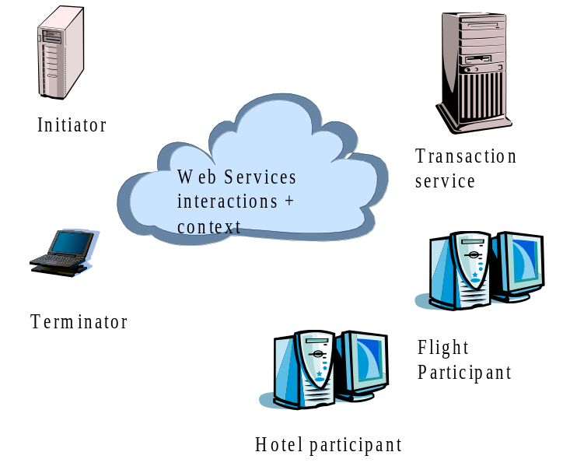
Figure 1: Web Services transaction actors.
In general a business transaction requires the capability for certain participants to be structured into a consensus group, such that all of the members in such a grouping have the same outcome. For example, consider the case shown in Figure 1, where a transaction is begun by an initiator to book a hotel room and a flight. Both of these actions are required or neither is, i.e., no partial outcome will be tolerated. The hotel and flight booking web services are therefore required to enrol respective participants with the transaction. The terminator (typically the same as the initiator) ends the transaction, the transaction service will ensure that both participants reach the same outcome (whether or not it is a successful outcome).
Importantly, different participants within the same business transaction may belong to different consensus groups. The business logic then controls how each group completes. In this way, a business transaction (driven, for example, by a workflow system) may cause a subset of the groups it naturally creates to perform the work it asks, while asking the other groups to undo the work.

When ACID is too strong
Consider the case of an on-line bookshop which reserves books for an individual for a specific period of time, but if the individual does not purchase the books within that time period they will be “put back onto the shelf” for others to purchase. Furthermore, because it is not possible for anyone to have an infinite supply of stock, some examples of on-line shops may appear to users to reserve items for them, but in fact if other users want to purchase them first they may well be allowed to (i.e., the same book may be “reserved” for multiple users concurrently); a user may subsequently find that the item is no longer available, or may have to be ordered in specially for them. If these example applications were modelled using atomic transactions, then the reservation process would require the book to be locked for the duration of the atomic transaction, and hence it would have to be available, and could not be acquired by (sold to) another user. When the atomic transaction commits, the book will be removed from stock, and mailed to the user. However, if a failure occurs during the commitment protocol, the book may remain locked for an indeterminate amount of time (or until manual intervention occurs).
It has long been realised that ACID transactions by themselves are not adequate for structuring long-lived applications. To ensure atomicity between multiple participants, a multi-phase (typically two) consensus mechanism is required, as illustrated in Figure 2: during the first (preparation) phase, an individual participant must make durable any state changes that occurred during the scope of the atomic transaction, such that these changes can either be rolled back (undone) or committed later once consensus to the transaction outcome has been determined amongst all participants, i.e., any original state must not be lost at this point as the atomic transaction could still roll back. Assuming no failures occurred during the first phase (in which case all participants will be forced to undo their changes), in the second (commitment) phase participants may make the new replace the original state with the new durable state.
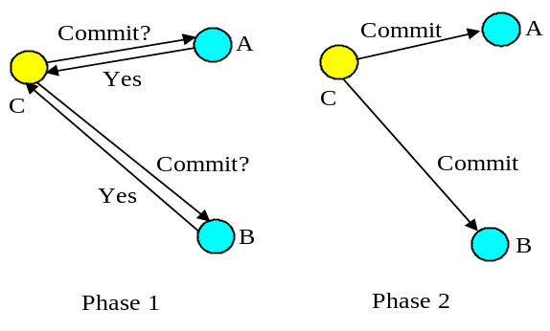
Figure 2: Two-phase commit protocol.
In order to guarantee consensus, two-phase commit is necessarily a blocking protocol: after returning the phase 1 response, each participant which returned a commit response must remain blocked until it has received the coordinator’s phase 2 message telling it what to do. Until they receive this message, any resources used by the participant are unavailable for use by other atomic transactions, since to do so may result in non-ACID behaviour. If the coordinator fails before delivery of the second phase message these resources remain blocked until it recovers. In addition, if a participant fails after phase 1, but before the coordinator can deliver its final commit decision, the atomic transaction cannot be completed until the participant recovers: all participants must see both phases of the commit protocol in order to guarantee ACID semantics. There is no implied time limit between a coordinator sending the first phase message of the commit protocol and it sending the second, commit phase message; there could be seconds or hours between them.
Therefore, structuring certain activities from long-running atomic transactions can reduce the amount of concurrency within an application or (in the event of failures) require work to be performed again. For example, there are certain classes of application where it is known that resources acquired within an atomic transaction can be released “early”, rather than having to wait until the atomic transaction terminates; in the event of the atomic transaction rolling back, however, certain compensation activities may be necessary to restore the system to a consistent state. Such compensation activities (which may perform forward or backward recovery) will typically be application specific, may not be necessary at all, or may be more efficiently dealt with by the application.
For example long-running activities can be structured as many independent, short-duration top-level atomic transactions, to form a “logical” long-running transaction. This structuring allows an activity to acquire and use resources for only the required duration of this long-running activity. This is illustrated in Figure 3, where an application activity (shown by the dotted ellipse) has been split into many different, coordinated, short-duration top-level atomic transactions. Assume that the application activity is concerned with booking a taxi (t1), reserving a table at a restaurant (t2), reserving a seat at the theatre (t3), and then booking a room at a hotel (t4), and so on. If all of these operations were performed as a single atomic transaction then resources acquired during t1 would not be released until the top-level atomic transaction has terminated. If subsequent activities t2, t3 etc. do not require those resources, then they will be needlessly unavailable to other clients.
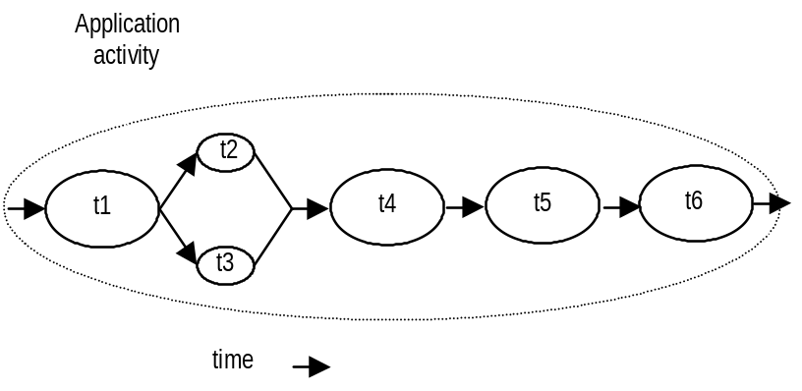
Figure 3: An example of a logical long-running “transaction”, without failure.
However, if failures and concurrent access occur during the lifetime of these individual transactional activities then the behaviour of the entire “logical long-running transaction” may not possess ACID properties. Therefore, some form of (application specific) compensation may be required to attempt to return the state of the system to consistency. A transactional workflow system can be used to provide scripting facilities for expressing the composition of these transactions with specific compensation activities where required. For example, let us assume that t4 aborts. Further assume that the application can continue to make forward progress, but in order to do so must now undo some state changes made prior to the start of t4 (by t1, t2 or t3). Therefore, new activities are started; tc1 which is a compensation activity that will attempt to undo state changes performed, by say t2, and t3 which will continue the application once tc1 has completed. tc5’ and tc6’ are new activities that continue after compensation, e.g., since it was not possible to reserve the theatre, restaurant and hotel, it is decided to book tickets at the cinema. Obviously other forms of composition are possible.
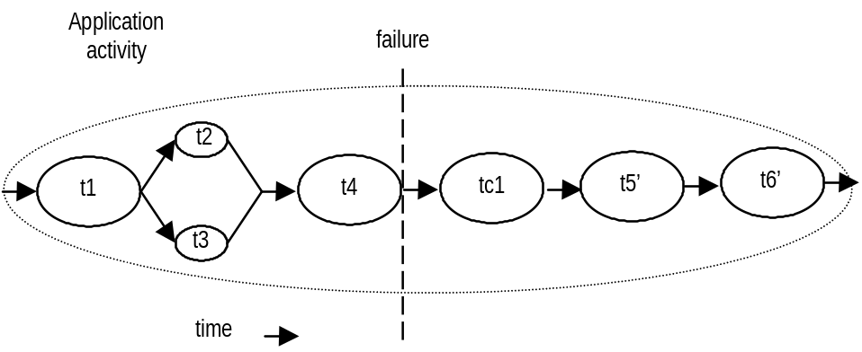
Figure 4: An example of a logical long-running “transaction”, with failure.
Other extended transaction models offer more natural support for additional application requirements. For example, consider the situation shown in Figure 5, where a user is booking a holiday, has provisionally reserved a flight ticket and taxi to the airport and is now looking for travel insurance. The first consensus group holds Flights and Taxi, since neither of these can occur independently. The user may then decide to visit multiple insurance sites (called A and B, in this example), and as he goes may reserve the quotes he likes. So, for example, A may quote $50, which is just within budget, but the user may want to try B just in case he can find a cheaper price, and without losing the initial quote. If the quote from B is less than that from A, the user may cancel A, while confirming both the flights and the insurance from B. Each insurance site may therefore occur within its own consensus group.
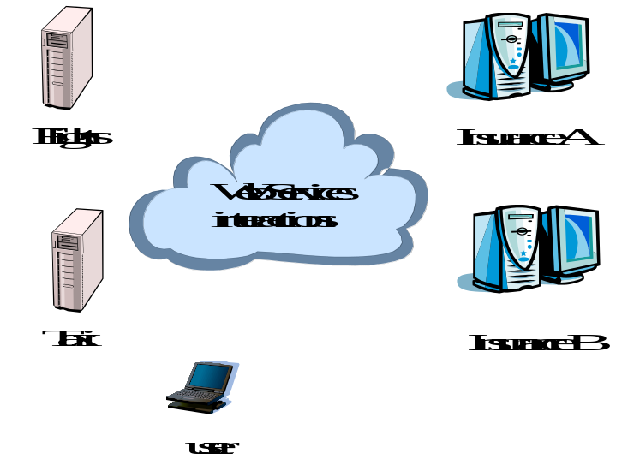
Figure 5: Flight booking.

Existing techniques
Much research on structuring applications out of transactions has been influenced by the ideas of spheres of control [5]. There are several ways in which some or all of the application requirements outlined above could be met [6][7][8][9][10].
- Independent top-level transactions: with this mechanism it is possible to invoke a top-level transaction from within another transaction [6][11]. If the invoking transaction rolls back, this does not lead to the automatic rollback of the invoked transaction, which can commit or rollback independently of its invoker, and hence release resources it acquires. Such transactions could be invoked either synchronously or asynchronously. In the event that the invoking transaction rolls back and compensation is required, compensating transactions may be invoked automatically by the transaction system or dealt with by the application.
- Glued transactions: long-running top-level transactions can be structured as many independent, short-duration top-level transactions, to form a “logical” long-running transaction; the duration between the end of one transaction and the beginning of another is not perceivable, and selective resources can be atomically passed from one transaction to the next [7]. This structuring allows an activity to acquire and use resources for only the required duration of this long-running transactional activity. In the event of failures, to obtain transactional semantics for the entire long-running transaction may require compensation transactions which can perform forward or backward recovery.
- Transactional workflows: a transactional workflow system can be used to provide scripting facilities for expressing the composition of an activity (a business process) out of other activities (which could be transactional), with specific compensation activities [8].
- Business transaction protocol: the OASIS Business Transaction Protocol [ref] introduced the notion of an open-top two-phase termination protocol. Work is conducted within the scope of atoms, which are similar to atomic transactions and have the same all-or-nothing guarantees. However, the outcome of atoms are controlled by cohesions which allow their selective confirmation or cancellation by explicitly driving the two-phase protocol over a period of hours, days etc.

Overall aim
Interestingly, from a user’s (client/service) point of view the differences in how the transaction protocols mentioned are coordinated and controlled are minimal: the user starts the transactional activity, communicates with services and propagates information about the transaction (the context), and terminates the transaction. Most differences occur between the transaction controller (the coordinator) and its enlisted participants. For example, does it use a two-phase or three-phase termination protocol?
What does it mean to a client to begin a BTP transaction, a JTA transaction, or a glued transaction, for example? In many cases the answer is very little, since much of the transactionality guarantees and semantic knowledge reside within and between the services and the coordinator with which the client interacts. Therefore, conceptually a single client implementation could interact with several different transaction services according to requirements placed on the application by: the services, the environment, the business needs etc. In a Web Services environment, the services used by a client may be dynamically selected based upon the transaction model(s) they support (e.g., specified in UDDI) by a layer between the client and the actual service, explicitly by the business logic etc. At the level of the client/user all they are typically interested in is starting a transaction and performing work within its scope, leaving the actual transactional specific aspects to the services and the coordinator.
As a result, this specification aims to provide an interface to these different transaction protocols that allows different implementations to be plugged in. If necessary the user can introspect the underlying implementation to determine specific attributes and properties, but we believe that typically this will not be necessary. In addition, if specific models require enhanced interfaces in order to operate, these can be obtained in a structured and well defined manner.
Importantly, the interfaces we provide will not be solely concerned with the front-end user. Specifically, they can be broken down into the following categories:
- The front-end user (client).
- The service.
- The participant.
- The transaction controller (e.g., coordinator).
This specification does not provide a means whereby existing implementations can be provided to Web Services and their users via SOAP and XML since it is assumed that this has been done elsewhere in other specifications. Neither is it meant to place additional requirements on such implementations (e.g., BTP). What JAXTX does accomplish is to allow these implementations, which may have their own APIs, to be plugged into a common services architecture. The relationship between JAXTX and its underlying transaction service implementation is essentially the same as that which exists between the JTA and JTS specifications: JTA is the higher-level API which may use any transaction service implementation, although the JTS is the preferred option for interoperability.
The appendices of this specification contain protocol specific information for Java Web Services transaction implementations that do not occur in other specifications. For example, a definition of how components of the JTA/JTS specifications may be incorporated into Web Services, allowing the implementation of ACID Web transactions and services.

JAXTX architecture
Figure 6 illustrates a typical configuration for a transactional Web Service application. There is obviously a requirement for an application service (e.g., a flight booking service), and the client that will use it (their interactions are shown in red). In addition, there must be some transaction coordination service responsible for ensuring that the work performed by the client occurs in some manner consistent with the underlying transaction model (e.g., that it either happens or does not despite failures). Collaboration between the coordinator service and some application service specific participant will also be required.
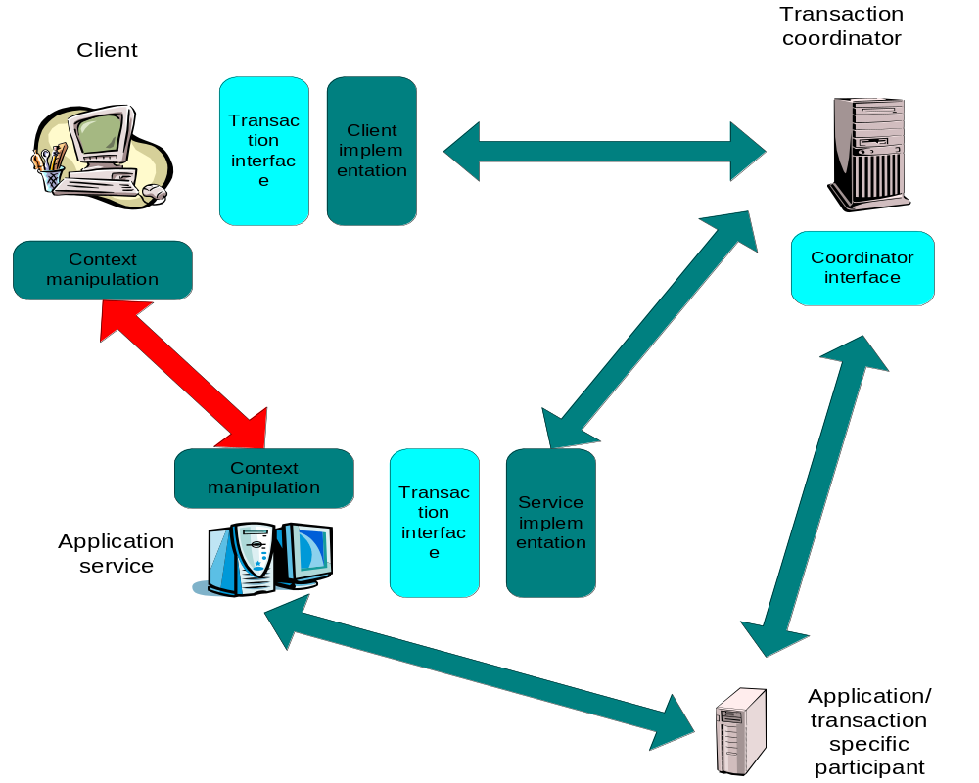
Figure 6: Applications and implementation components.
It is envisioned that in most situations the dark blue areas are already provided by existing standards and systems. For example, the OASIS Business Transactions Protocol defines precisely how the transaction context appears in transmitted XML documents, how coordinator specific messages are formatted, how participants behave under certain failure circumstances etc. However, the interfaces to these components will typically be defined in their specifications or may even be proprietary. JAXTX provides a uniform set of interfaces that are intended to indirect to the underlying implementations.
The generic interfaces, shown in light blue, are intended to allow users to concentrate on the functional aspects of interacting with different services, whereas the implementation specific interfaces will be used by service and participant implementers. Such implementers already have requirements and (possibly) programming interfaces placed on them by the protocols that they are using and JAXTX provides an extensible way in which these can be plugged into a JAXTX implementation. These implementations communicate with their underlying protocol specific equivalents, providing mappings to and from the generic interface and its types where appropriate. However, as will be shown, it is possible for users to obtain direct access to a more appropriate, system specific interface if necessary.

Architecture components
The JAXTX architecture can best be described with reference to Figure 7.
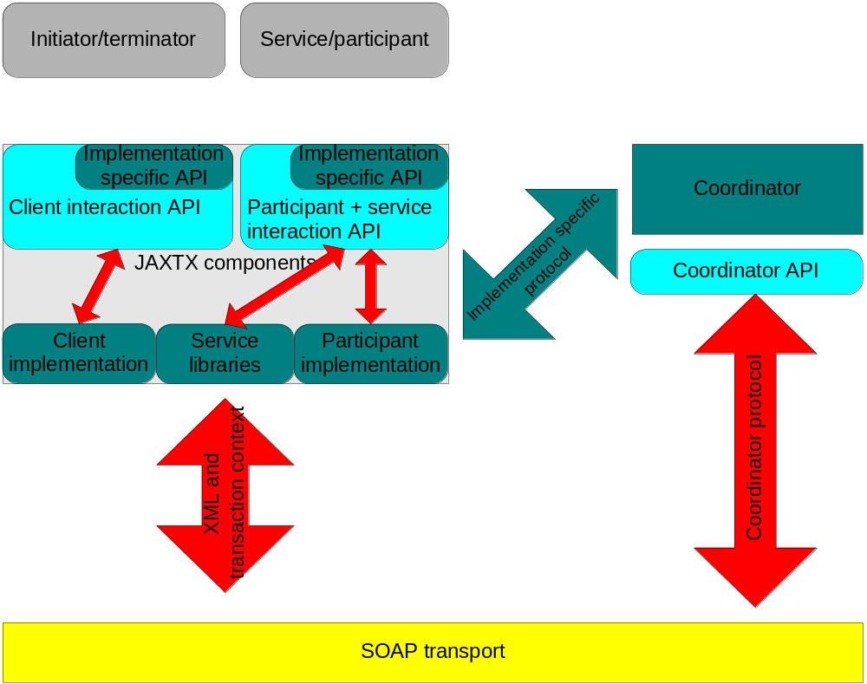
Figure 7: JAXTX architecture.
- The Web Service, e.g., the taxi booking service. Whenever a user contacts a service whose work it wishes to be under the control of a transaction, components of the transaction system are responsible for flowing the context (information about the transaction) to that service. The service can then use this information to enlist a participant with the transaction. Note, in the rest of this document we shall use the term container when referring to the entity that is responsible for hosting a specific service, receiving requests for it, etc. We do not make any assumptions about the implementation of such a container and shall attempt to talk in terms of JAXTX required functionality only. Note, a web service may play the role of a participant.
- The participant is the entity that actually does the real transaction work.
The Web Service (e.g., a theatre booking system) contains some business
logic for reserving a seat, enquiring availability etc, but it will need to
be back-ended by something that maintains information in a durable manner.
Typically this will be a database, but it could be a file system, NVRAM, etc.
Now, although the service may talk to the back-end database directly, it cannot commit or roll back any changes it (the
service) makes, since these are ultimately under the control of the
transaction that scoped the work. In order for the
transaction to be able to exercise this control, it must have some contact
with the database in our example, and this is accomplished by the
participant. Each participant supports a termination protocol specific to the transaction model implemented by the coordinator (e.g., two-phase commit). In addition, the work that a participant performs when instructed by the coordinator that its transaction is terminating is dependant on its implementation (e.g., commit the reservation of the theatre ticket). The participant will then return an indication of whether or not it succeeded. Unlike in an ACID transaction model, some extended transaction models may allow participant implementations that do not have to guarantee that they can remain in a prepared state; an implementation may indicate that it can only do so for a specified period of time, and also indicate what action it will take (confirm or undo) if it has not been told how to finish before this period elapses.
- Associated with every transaction is a coordinator, which is responsible for governing the outcome of the transaction. It communicates with enlisted participants to inform them of the desired termination requirements, i.e., whether they should accept (e.g., commit) or reject (e.g., roll back) the work done within the scope of the given transaction. For example, whether to purchase the (provisionally reserved) flight tickets for the user or to release them. This communication will be an implementation specific protocol (e.g., two or three phase completion).
- The initiator of the transaction communicates with a transaction manager and asks it to start a new transaction. The transaction scopes the consensus group described previously. Once created, information about the transaction (the context) can be propagated to web services in order for them to associate their work with it, i.e., work is conducted within the scope of a specific transaction.
- The terminator of the transaction is responsible for determining the desired outcome of the transaction and communicating this request to the transaction coordinator. The outcome of the transaction may not be as originally requested. This will typically be the same entity as the initiator, but need not be, e.g., a long running stock purchase transaction may be started by the company that requires the stock, and finished by the company that delivers it.
- The context and coordinator-to-participant protocol are implementation specific and have a format that is typically specified in other protocol documents, e.g., BTP [ref]. It is not the domain of this specification to impinge on these protocols and require changes to them. As such, it is assumed that these will be specified elsewhere and relevant JAXTX component implementations will conform to them. This specification does not attempt to provide a means whereby such protocol differences can be supported by a single implementation, since this is the domain of other specifications [jsr95][omgas]. This allows existing transaction systems to be plugged into a JAXTX implementation unmodified: all that is required is a standardisation of the specific coordinator-to-participant interface, which will already have been agreed upon by the designers of the transaction system in question, and for which JAXTX does provide some support.

Users and interfaces
JAXTX defines a set of interfaces which may be categorised as follows:
- Client: these interfaces provide new and existing clients with a uniform means by which they may access and use client-specific functionality from different transaction implementations.
- Service: these interfaces provide services with a uniform means by which services may access service-specific functionality from different transaction implementations. For example, a service provider may be able to support multiple different transaction protocols and use different participants for each; when the transaction implementation is imported by the service, it may determine the type of the transaction and act accordingly.
- Coordinator-participant: these interfaces enable the creation of coordinators that can function within different transaction implementations and hence drive different participant implementations.
Each set of interfaces offers useful features to different types of implementer and it is not envisioned that all interfaces will be useful for all users. For example, we believe that the majority of users of JAXTX will probably only use the client specific interfaces. However, in order to provide a complete Web Services transaction interaction API, all of the interfaces must be defined.

Combining implementations
Since we believe that there will be several different transaction implementations co-existing within the Web Services environment, it is logical to assume that some applications and services may require their use concurrently. As such, the JAXTX architecture does not place any limitations on the number of transaction implementations that may be utilised within a single application or JVM. Whether or not it makes sense for multiple implementations to co-exist, or for how they may inter-work (assuming inter-working is required) is beyond the scope of the JAXTX specification.

JAXTX components

Features
The features provided by JAXTX to support the plugging of different transaction implementations within the architecture are described in this section, with reference to Figure 7.

Client interaction interface
Despite the variety of transaction implementations, the interfaces that most clients use to interact with them are very similar. These typically involve: starting and ending a transaction (possibly terminating in multiple ways, e.g., commit or roll back), and associating/disassociating a transaction with/from the current thread of control. The UserTransaction is responsible for encapsulating this common functionality within a single interface. An implementation of the UserTransaction is responsible for mapping the JAXTX requirements to the underlying implementation. The UserTransaction then interacts with the coordinator service when instructed to by the client using whatever SOAP/XML protocol is required by the service implementation it encapsulates.
The client component of an application requires some means by which the transaction context is associated with any outgoing service invocation. As described earlier, the format of the context, where it occurs within an XML invocation document etc. will be specified by the appropriate implementation. The UserTransaction is required to encapsulate this context manipulation in a transparent manner to the client, such that as far as the client is concerned, the context flows implicitly with all relevant invocations.

Extended client interfaces
Some transaction implementations may require extensions to the general UserTransaction interface. For example, in the OASIS BTP there is scope for the client application to drive the two phase completion protocol explicitly, rather than leaving it to the coordinator as typically happens in other models. Thus, there is a requirement for more than simply telling the transaction coordinator to end.
In order to determine the properties of the underlying implementation, the UserTransaction configuration and properties are available in the form of a org.w3c.dom.Document. If the client requires access to protocol specific interfaces that the implementation supports, then it can either cast the underlying implementation to a well known interface (e.g., the interfaces specified in Section XX) or use reflection to obtain access to the extensions.

Generic coordinator interface
As with the client, there are some similarities as to how a service or participant interacts with a transaction coordinator. However, this generality is on a smaller scale than for the front-end client, typically involving only registering and un-registering participants. These methods are provided by the TransactionManager interface, and as with the UserTransaction, services are expected to safely cast, or reflect over, the basic interface to a more protocol specific version if necessary. All configuration information is made available via an instance of the org.w3c.dom.Document.
As with the UserTransaction, TransactionManager implementations are expected to communicate with protocol specific counterparts. However, we do not require that a coordinator will only support a single type of participant. It is possible that a single coordinator may be able to drive multiple types of participant (e.g., two-phase or three-phase). However, a given service may try to enlist the wrong type of participant, and as such the coordinator is responsible for returning an indication of why the registration has failed. The type of participant(s) that a coordinator implementation supports may be made available via its XML configuration document.

Participant interface
The coordinator-to-participant protocol is extremely transaction model specific and leaves little room for generality. As such, the Participant interface is essentially a handle for the more specific participant implementation. The TransactionManager is expected to determine that the Participant is of a type that it can work with (through the available XML configuration information) and then safely narrow the Participant to the specific type. If the coordinator does not support the type of participant that is attempted to be enrolled with it, then the coordinator is required to fail the enrolment and indicate the reason why.

Service and context management interface
As shown in Figure 6, the transactional Web Service will require context manipulation functionality, typically provided by the container that the service resides within. As with the client, this context manipulation is expected to be transparent to the service.

XML configuration data
TBD

JAXTX packages
The JAXTX specification defines four new javax packages, described briefly in the following sections and in more detail in the associated javadoc which accompanies this specification. The javax.jaxtx package contains interfaces and classes to which an implementer of JAXTX must conform. The javax.jaxtx.as, javax.jaxtx.jta and javax.jaxtx.btp contain implementation specific enhancements for transaction models conforming to the Activity Service [ref], JTA [ref] and BTP [ref] specifications respectively.

javax.jaxtx package
The classes and interfaces of the javax.jaxtx package are required to abstract away from implementation specific details of the underlying transaction model, as illustrated in Figure 6. All classes provided by implementers will conform to one or more of these interfaces. These are summarized in this section and described in full in the accompanying javadoc.

CompletionStatus
The CompletionSatus interface and associated classes define the basic modes in which a transaction can terminate.
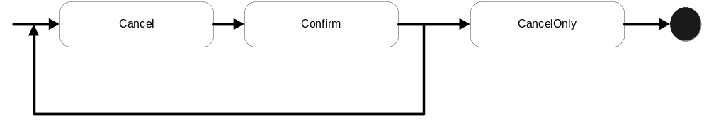
Figure 8: CompletionStatus state diagram.
As shown in Figure 8, at any time in its life a transaction can be in one of three completion states, to be described below, such that if it is asked to complete (explicitly by the user or implicitly by virtue of failures) it will do so in a manner prescribed by that state:
- ConfirmCompletionStatus: the transaction should complete in a successful state, i.e., all work performed within its scope should be accepted. Note, that if nesting of transactions is supported, this does not necessarily mean that any state changes are made permanent [moss]. When in this state, the transaction may be transitioned into any other state. Note, if the transaction cannot complete in this state then it will transition to the CANCEL state.
- CancelCompletionStatus: the transaction should complete in a failure state, i.e., all work performed within its scope should be undone in an implementation specific manner. When in this state, the transaction may be transitioned into any other state. This is the default completion state in which all transactions begin.
- CancelOnlyCompletionStatus: the transaction should complete in a failure state, i.e., all work performed within its scope should be undone in an implementation specific manner. Once in this state, the transaction state cannot transition any further.
Note, it is possible that a specific transaction model may have additional states in which is can complete, and these should be available to JAXTX users. Therefore, in order to ensure extensibility and that required state transitions do not conflict (e.g., state foo for one transaction model may mean something different for another), state types are specified as class implementations of the CompletionStatus interface.

Status
The state of a transaction at any point in its life is determined by the Status class and its associated implementations, as illustrated in Figure 9.
- ActiveStatus: the transaction initially starts in this state. An implementation returns this value prior to the coordinator entering a termination protocol or being marked as CancelOnly.
- MarkedCancelOnlyStatus: the transaction has been forced into a state whereby its eventual completion must be to cancel, i.e., CancelOnly.
- CompletingConfirmStatus: the transaction transitions to this state when told to complete and the completion status is Confirm. The transaction will remain in this state until it has completed in one termination outcome or another. If it cannot complete in the Confirm state then the transaction will transition to the Cancel state and complete. For example, in a two-phase completion protocol if the first phase (prepare) succeeds then the coordinator will commit (confirm) all state changes; if it fails then the coordinator will rollback (cancel) all state changes. If there are no failures, the transaction will typically remain in this state until it has received all responses to its termination protocol.
- CompletedConfirmStatus: the transaction has terminated successfully in the Confirm completion status. If this status is returned from a call to UserTransaction.status then it is likely that errors specific to the protocol exist (e.g., heuristics); otherwise the transaction would have been destroyed and NoTransactionStatus returned.
- CompletingCancelStatus: the transaction transitions to this state when told to complete and the completion status is Cancel. The transaction will remain in this state until it has completed.
- CompletedCancelStatus: the transaction has terminated successfully in the Cancel completion status.
- NoTransactionStatus: there is no transaction associated with the invoking thread.
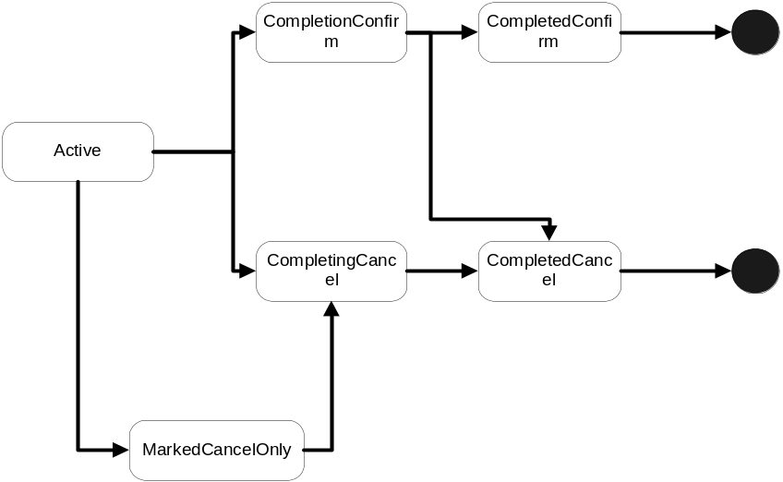
Figure 9: Transaction status transitions.
Note, it is possible that a specific transaction model may have additional states in which the transaction can be, and these should be available to users. Therefore, in order to ensure extensibility and that required state transitions do not conflict, state types are implementations of the Status class.

Outcome
When a user informs a transaction to terminate, the act of termination may return information to the user. This information may be present both for successful and unsuccessful termination of a transaction. For example, in an implementation of the JTA protocol for Web Services, the ConfirmCompletionStatus state for a transaction would correspond to committing the transaction and a successful outcome to this would return no information. However, an unsuccessful termination, for example because of participant failures, could return a specific heuristic exception [jta].
In order to support the different transaction model requirements for return types, UserTransaction is required to return an instance of classes derived from the Outcome interface. The types of Outcome and their internal encoding are required to be specified by the definer/implementer of the transaction implementation.
The type of the transaction Outcome is obtainable from the name method, whereas the actual state in which it terminated is available from the completedStatus method; a user may want the transaction to complete in a ConfirmCompletionStatus state but the eventual outcome is determined by the coordinator and its participants such that failures or inabilities to complete the ConfirmCompletionStatus protocol may result in the transaction ending in a CancelCompletionStatus state.
Additional implementation specific data is made available in the form of an XML document (instance of org.w3c.dom.Document) through the data method. The user may obtain and parse this document to determine additional information on how the transaction terminated.

TxHandle
TxHandle is used as a representation of a transaction (or stack of transactions) when it is suspended from a running thread. The implementation of the token can be as lightweight as required by the underlying implementation in order that it can uniquely represent all transaction instances. Since this is a client-facing class, it is unlikely that the application user will typically want to see the entire transaction context in order to simply suspend it from the thread.

UserTransaction
The UserTransaction is the interface that most users (e.g., clients and services) will see. This isolates them from underlying protocol specific aspects of the transaction implementation they are using. If required, an underlying implementation may provide additional methods to users, who may cast or reflect to the underlying implementation if necessary. Importantly, a UserTransaction does not represent a specific transaction, but rather is responsible for providing access to an implicit per-thread transaction context; it is similar to the UserTransaction in the JTA specification [ref]. Therefore, all of the UserTransaction methods implicitly act on the current thread of control.
A new transaction is begun and associated with the invoking thread by using the start method. A transaction that is already associated with the invoking thread will become the parent of this newly created transaction, i.e., the new child transaction is nested within the parent. If nesting is not supported or available (e.g., the implementation reaches a nesting limit imposed by the transaction model being used), then the javax.jaxtx.NestingNotAllowedException is thrown. The state of the parent transaction may be such that it is invalid for a new transaction to be created within its scope (e.g., the parent is in the process of terminating) and in this situation the javax.jaxtx.InvalidStateException is thrown.
The setTimeout method modifies a state variable associated with the UserTransaction that affects the time-out period in seconds associated with the transaction created by subsequent invocations of the start method. If parameter has a non-zero value and the transaction has not begun to terminate before this time period has elapsed, it will be completed in the CancelCompletionStatus mode. If the timeout period is invalid or not supported, then the javax.jaxtx.InvalidTimeoutException is thrown. A value of zero means that no application specified time-out is established.
The getTimeout method returns the timeout value currently associated with the UserTransaction.
The state in which the current transaction should be completed is set using the setCompletionStatus method and passing in either one of the CompletionStatus defined types or one specific to the model being used. If the completion state is invalid given the state of the transaction (e.g., it has already begun to complete) then the javax.jaxtx.InvalidStateException will be thrown. The completion status of the transaction currently associated with the invoking thread can be obtained from the getCompletionStatus method. As shown in Figure 8, if there has been no call to the setCompletionStatus then the default completion status is CancelCompletionStatus. If there is no transaction associated with the current thread then the javax.jaxtx.NoTransactionException is thrown by both methods.
A transaction can be told to complete using the end method, which will also disassociate the thread from the transaction. The completion status the transaction implementation uses will either have been set by a previous call to setCompletionStatus, may be provided as a parameter to end, or will be the default of CancelCompletionStatus. If this is a top-level transaction, i.e., it has no parent, then upon completion the thread will have no transaction associated with it. If no transaction is associated with the current thread then the javax.jaxtx.NoTransactionException is thrown.
Some transaction models may restrict the ability for threads to end transactions, e.g., such that only the transaction creator may terminate the transaction (c.f. checked transactions in the OTS). If this is the case, the implementation will throw the javax.jaxtx.NoPermissionException. If the specified completion state of the transaction is not compatible with the transaction’s state (for example, its completion state is CancelOnlyCompletionStatus and the user has asked the transaction to terminate with a status of CompletionStatus.SUCCESS), or the state of the transaction does not allow it to be terminated, then the javax.jaxtx.InvalidStateException will be thrown.
Obviously a transaction may not be able to complete in the state originally requested by the user. When the transaction terminates it may return an Outcome object to indicate how it did complete. It is valid for end to return a null Outcome. A transaction that completes and does not return an Outcome or throw an exception is assumed to have completed successfully in the manner requested.
A thread of control may require periods of non-transactionality so that it may perform work that is not associated with a specific transaction. In order to do this it is necessary to disassociate the thread from any transactions. The suspend method accomplishes this, returning a TxHandle instance, which is a handle on the transaction. If the current transaction is nested, then the TxHandle will implicitly represent the stack of transactions up to and including the root transaction. The thread then becomes associated with no transaction.
The resume method can be used to (re-)associate a thread with a transaction(s) via its TxHandle. Prior to association, the thread is disassociated with any transaction(s) with which it may be currently associated. If the TxHandle is null, then the thread is associated with no transaction. The javax.jaxtx.InvalidTransactionException is thrown if the transaction that the TxHandle refers to is invalid in the scope of the invoking thread. Obviously the validity or not will be dependant on the underlying transaction implementation to determine.
The getTransactionHandle method returns the TxHandle for the current transaction, or null if there is none. Unlike suspend, this method does not disassociate the current thread from the transaction(s). This can be used to enable multiple threads to execute within the scope of the same transaction.
The current status of the transaction is returned by the status method. If there is no transaction associated with the thread then NoTransactionStatus is returned. It is possible that the exact determination of a transaction’s status is not possible when status is invoked and in which case UnknownStatus is returned. This is a transient value and calling status again will eventually return the transaction’s status.
Every transaction is required to have a unique identity, which can be obtained from the globalIdentity method. However, in order to ensure that transaction identifiers are unique across all transaction models, the value returned by globalIdentity is required to be prefixed with the package name of the transaction implementation. For example, “javax.jaxtx.1234” or “javax.jaxtx.jta.1234”. If there is no transaction associated with the current thread then null will be returned.
In addition to globalIdentity, the transactionName method can be used to obtain a more user-friendly representation of the transaction. This may return the same as globalIdentity or more return other information more suitable for debugging purposes, for example. If there is no transaction associated with the current thread then null will be returned.
The parent of the current transaction is returned by getParent. If the current transaction has no parent, i.e., is a top-level transaction, then null is returned. If there is no transaction associated with the invoking thread then the javax.jaxtx.NoTransactionException is thrown.
Fundamental to the JAXTX architecture is the notion of a transaction context. As illustrated in Figure 10, each thread is associated with a context via UserTransaction. This association may be null, indicating that the thread has no associated transaction, or it refers to a specific transaction. Contexts may be shared across multiple threads. In the presence of nested transactions a context remembers the stack of transactions started within the environment such that when the nested transaction ends the context of the thread can be restored to that in effect before the nested transaction was started.
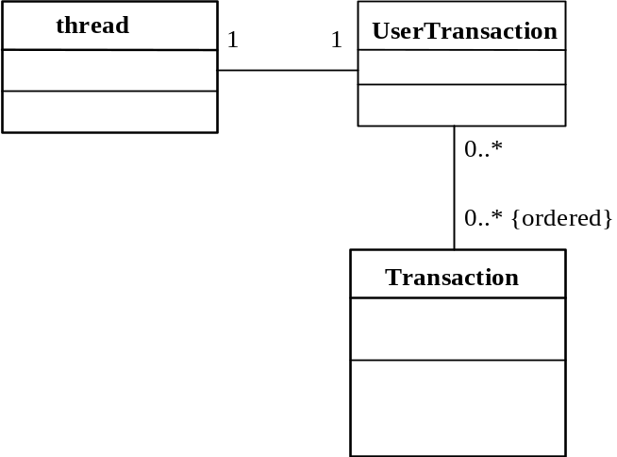
Figure 10: Thread and context relationship.

UserTransactionFactory
UserTransactions are obtained from a UserTransactionFactory, which is made available via JNDI lookup of java:comp/UserTransactionFactory. The UserTransaction corresponding to the specific transaction type is returned from the factory’s getTransactionType method, as defined in the associated XML document configuration. If no such transaction type is provided by the factory, then the javax.jaxtx.NoSuchServiceException is thrown. Alternatively, all of the transaction types supported by the factory may be returned through the getAllTransactionTypes method. The factory may restrict the accessibility for clients to obtain all transaction types through this method and throw the javax.jaxtx.InvalidSecurityOptionException.

Participant
As shown in Figure 6, the protocol between transaction coordinator and participant will be extremely implementation specific. Therefore, rather than attempt to provide a generic and potentially overly complex interface to a participant, the Participant interface is provided so that implementations can identify themselves as participants to a coordinator. The coordinator implementation is expected to use associated XML configuration information (available via the configuration method) to determine whether or not the participant implementation has the right higher-level interface, and if so to use it.

Transaction
The Transaction interface provides a means whereby Participants may be enrolled with a specific transaction. Unlike UserTransaction, a Transaction does represent a specific transaction. This isolates them from any underlying protocol specific aspects of the implementation they are using. If required, an implementation may enhance this interface and provide additional methods to users.
A Participant is enrolled with a transaction using the enlist method; if the coordinator is not in a state where enrolment is possible (e.g., it is terminating) then the javax.jaxtx.InvalidStateException will be thrown. Additional protocol specific information required to perform the enrolment is provided in the form of an XML document. As mentioned in Section 4.2.1.7, the coordinator implementation is expected to narrow the actual Participant interface to a protocol specific version with which it can work. If the Participant is not a valid type for the coordinator (i.e., it does not support the right syntactic methods and their semantic meaning) then the javax.jaxtx.InvalidParticipantException is thrown and the Participant will not be enrolled with the transaction.
Some transaction protocols allow for an enrolled Participant to leave a transaction. This may be accomplished through the delist method. If the coordinator is not in a state where leaving is valid, or the transaction protocol simply does not support Participants leaving, then the javax.jaxtx.InvalidStateException is thrown, and in this situation the Participant should continue to honour the protocol requirements for an enrolled transaction member. If the Participant is invalid within the context of the coordinator implementation then the javax.jaxtx.InvalidParticipantException will be thrown. A coordinator that does not know about the Participant must throw the javax.jaxtx.UnknownParticipantException in order to distinguish between the two failure conditions.

TransactionManager
The TransactionManager interface represents the service/container/participant’s (service-side users) typical way in which to interact with the underlying transaction service implementation. It derives from the UserTransaction and so service-side users can create new transactions, suspend existing transactions etc.
As shown in Figure 11, it is the service container’s responsibility to ensure that any imported transaction context is made available to the service via the TransactionManager implementation. In the figure, a client begins a new transaction via UserTransaction.begin() and then invokes a method (foo) on the remote service. The request, along with the transaction context, is transmitted between the client and the service using a protocol specific to the application environment (e.g., SOAP over HTTP).
In a typical transactional application implementation, the incoming service request is intercepted (e.g., by the service container or interceptor), the context is stripped off and a proxy for the imported transaction is created; this proxy is then associated with the thread of control that performs the actual work. Other protocol specific work may also be performed, such as registering a participant or performing interposition [ref].
In a JAXTX environment, all of the above work is obviously performed within the implementation specific layer. The JAXTX implementation of TransactionManager is required to utilise this layer in order to be able to present the service with a representation of the current transaction when, and if, required. Note, this may simply be a reference to the original (imported) transaction.
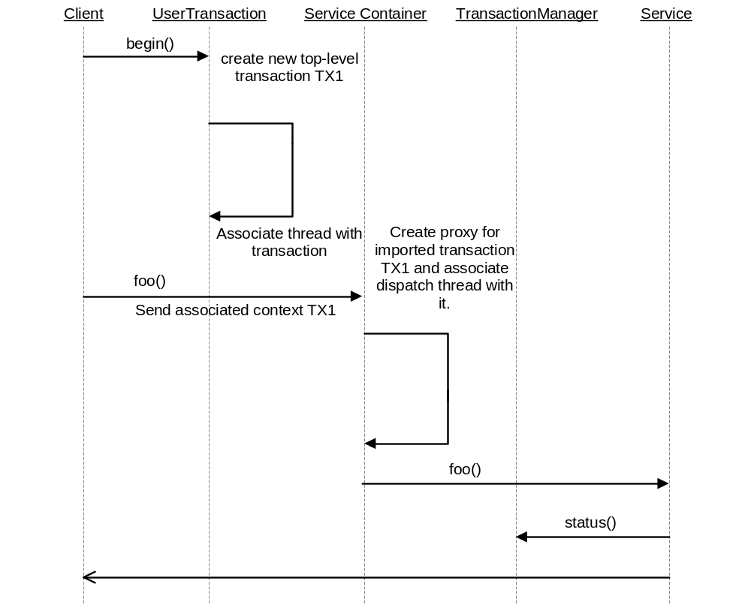
Figure 11: Containers and imported transactions.
In order to register participants with a transaction, the container or participant must use the relevant Transaction instance. This is obtained using the getTransaction method.

Exceptions
The following exceptions and their meanings are used by JAXTX:
- InvalidParentException
- InvalidParticipantException
- InvalidSecurityOptionException
- InvalidStateException
- InvalidTimeoutException
- InvalidTransactionException
- NestingNotAllowedException
- NoPermissionException
- NoSuchServiceException
- NoTransactionException
- SystemException
- UnknownParticipantException

Transaction model definitions

References

Atomic, Consistent, Isolated, Durable.

